**Border Model of Website Styling**

This model is used to styling the website.

Clockwise

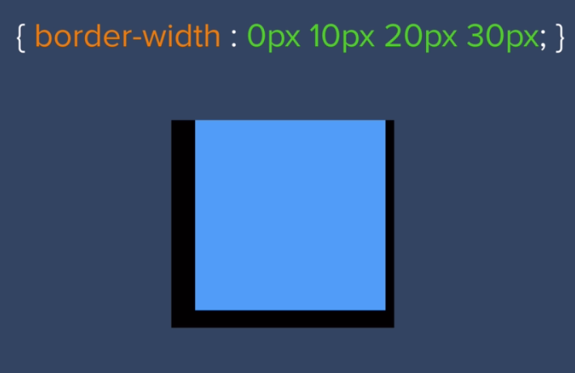

It is 20 pixels space around margins (between the text and edges).

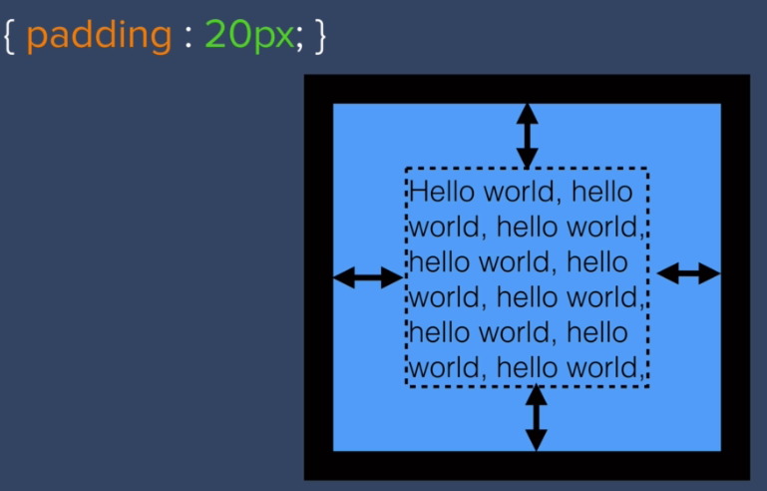

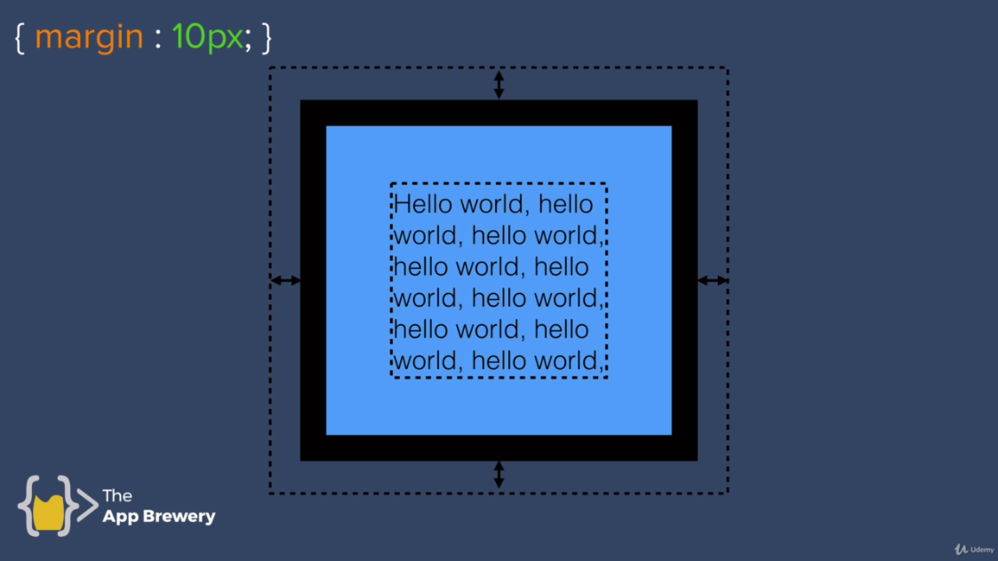

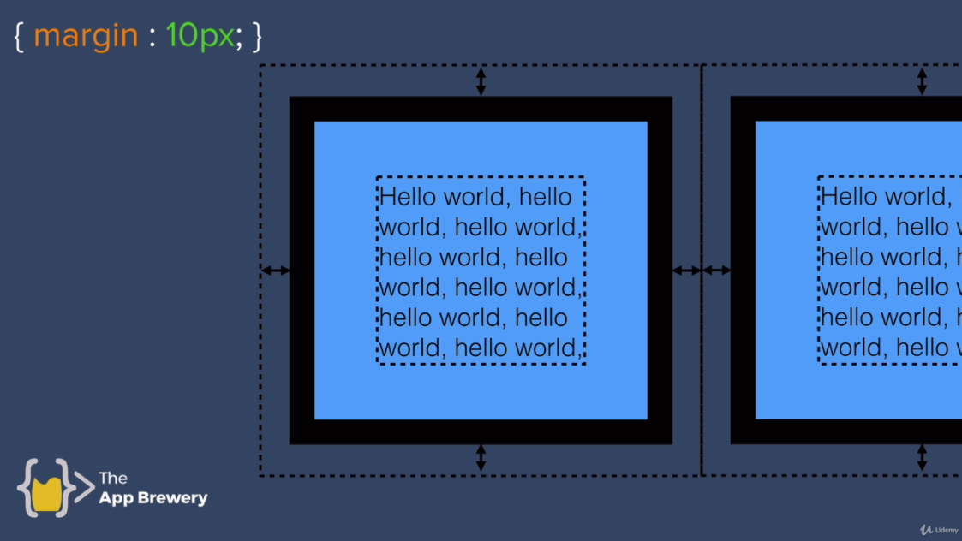

<https://markusvogl.com/web1/interactive-box-model/css-box-demo.html>

BSASIC CSS BOX MODEL DEMO learn from above website.

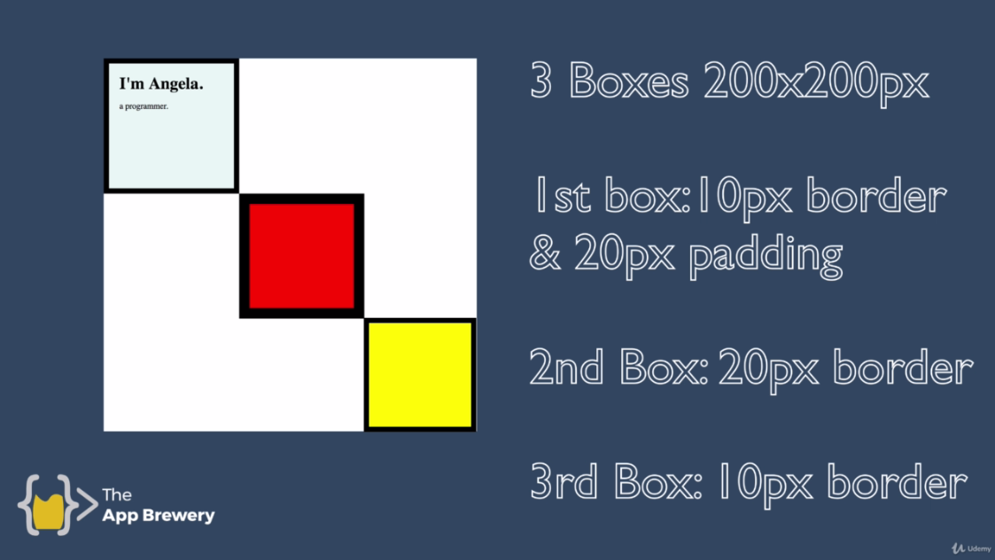

**Code:**

**Styles1.css:**

/**************************** TAG SELECTORS *******************************/

body{

/*background-color: blue;*/

margin: 0;

}

h1{

margin-top: 0;

}

/**************************** CLASS SELECTORS *******************************/

.top-container{

background-color: #E4F9F9;

width: 200px;

height: 200px;

border: solid 10px;

}

.middle-container{

background-color: red;

width: 200px;

height: 200px;

border: solid 20px;

margin-left: 220px;

}

.bottom-container{

background-color: blue;

width: 200px;

height: 200px;

border: solid 10px;

margin-left: 460px;

}

**Index1.html:**

<!DOCTYPE html>

<html lang="en" dir="ltr">

<head>

<meta charset="utf-8">

<title>Muhammad Ahmad</title>

<link rel="stylesheet" href="css/styles1.css">

<link rel="icon" href="favicon1.ico">

</head>

<body>

<div class="top-container">

<h1>I'm Muhammad Ahmad.</h1>

<p>a web-designer.</p>

</div>

<div class="middle-container">

</div>

<div class="bottom-container">

</div>

</body>

</html>